**“Experiment 5: Harmonic Oscillator, Part I: Spring Oscillator”**

Christina Oliveira; UID: 204-803-448

October 31, 2017

Tuesday 9AM

TA: Paokuan Chin

Lab Partner: Rosanna Rico

Abstract Word Count: 127 ----Total Word Count: 2260

Christina Oliveira

**Experiment 5: Harmonic Oscillator, Part I: Spring Oscillator**

**Abstract**

**Experimental and Predicted Values for Damped and Undamped Spring Oscillations**

C. Oliveira1

A damped harmonic oscillator is an oscillator whose amplitudes decay over time due to an external damping force working against the restoring force of the system. The Q-factor, Q, of this kind of system is an indication of the quality of a damped oscillators resonance. In this experiment, a spring oscillator is examined in both its damped and undamped states in order to compare the calculated and expected values of the resonant frequency and the undamped frequency, and to calculate the Q-factor of the damped oscillation. The frequencies were found to be indistinguishable because they were within each other’s uncertainties, and Q was found to be 10.98±.06. These results confirmed the validity of the given equation that modeled damped harmonic oscillations with a high degree of preciseness.

1*Departmentof Electrical Engineering, University of California Los Angeles*

**Introduction**

A harmonic oscillator is a system with a mass that experiences a restoring force proportional to the mass’s displacement from equilibrium. Simple harmonic oscillators experience no damping and will continue to oscillate indefinitely. Damped harmonic oscillators experience a gradual decay in amplitude over time as some force diminishes the magnitude of the restoring force. This force, known as the damping force is defined as:

$$F_{damp}=-bv$$

where *v* is the velocity of the oscillating mass in m/s2 and *b* is the damping term in kg/s. The damping term is constant in any damped system and gives an indication of how long it would take to completely damp out an oscillation.

These systems have been studied in detail for decades, as they are very common and fairly simple to model. They can be modeled by springs, pendulums, and many other systems that involve a rhythmic transfer of potential to kinetic energy.

In this experiment, damped and undamped oscillations are observed and the damping terms calculated and compared. The oscillator used is a magnetic mass attached to a spring. Damping is introduced to the system by enclosing the oscillation in an aluminum tube that is non-magnetic. This force created acts as the damping force in this experiment. The damping terms can be calculated by observing the damping rate, which is the decay of the amplitudes of the motion over time, of the system experimentally, which is what is done in this experiment. Specifically, in this experiment, we attempt to validate Eq. 5.2 from the lab manual by calculating the damped and undamped frequencies both experimentally and theoretically and comparing these two values.

**Methods**

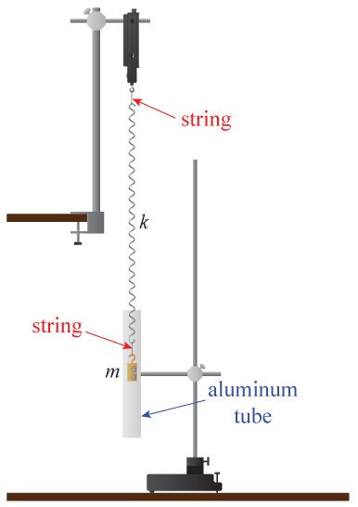

Figure 1. Magnetically Damped Harmonic Spring Oscillator Setup. The force sensor was set up as shown, suspended vertically from the lab table. A spring with spring constant k was then attached to it via a piece of twine in order to decouple any rotation. A mass, m, with strong magnets embedded in it, was suspended, again, with twine, from the other end of the spring as shown. For the damped motion, an aluminum tube was suspended around the mass as is oscillated in order to introduce a damping force without introducing friction.

First, the mass with embedded magnets was weighed. The spring system was then set up by connecting the spring to a force sensor using a small piece of twine. The spring constant, k, of the spring was then found experimentally by suspending five different masses on the other end of the spring by using another piece of twine and recording the displacement from the floor to the bottom of the mass for each suspended mass. The force sensor was then tared and the magnetic weight suspended from the other end of the spring, again connected by a string. The mass was then pulled up from its equilibrium position and then dropped, allowing the system to oscillate. The system was allowed about 10 seconds to stabilize and then 20 seconds of voltage and time data was recorded. A sample rate of 20.4 Hz was chosen so that the extrema were clearly visible. Keeping the sample rate constant, an aluminum tube was added to the system to encapsulate the mass as it oscillated as shown in Figure 1. The weight was again raised, dropped, and allowed to oscillate for 20 seconds while voltage vs. time data was recorded. The aluminum tube turned the simple oscillator into a damped oscillator, since it is an anti-magnetic materiel, gradually slowing down the motion. The tube was placed in such a way that the mas never physically touched the inner walls of the tube. Then, the damped oscillation experiment was performed again, but this time, the frequency-domain representation of the data was recorded.

**Analysis**

**Data:**

Figure 2. Spring Constant Calculation via Mass Suspension The linear relationship between the force applied to the spring via a known suspended mass and the displacement from the floor to the bottom of the mass is plotted above. The orange dots show the fitline for this relationship. This fitline is of the form y=ax+b where a=-3.29±.01 N/m and b= 3.499±.008 N. These uncertainties were calculated by using the linear regression tool in Excel. The spring constant, k, of the spring has both statistical and systematic uncertainty since the mass of the weights used to calculate the forces had uncertainty. Therefore, the value for k, which is |a|, is 3.29±.04 N/m.

The mass of the hanging weight with magnets embedded was found to be .174 ± .001 kg.

The spring constant, k, was calculated as shown in Figure 2, by finding the slope of the line that describes the linear relationship between the force applied and the displacement. As shown, the spring constant, k, was calculated to be3.29±.04 N/m. Using equations and uncertainties derived below, the predicted value for the resonant frequency of the undamped oscillator, $f_{0}$, was found to be 0.69 ± .02 Hz

**Derivations:**

To find the predicted resonant frequency, *f0*, of an undamped oscillator in terms of the spring constant, k, and the mass, m, of the oscillator, the equation is fairly simple and can be derived like so:

$$f_{0}=\frac{ω}{2π}=\frac{1}{2π}ω=\frac{1}{2π}\sqrt{\frac{k}{m}}$$

Using the experimental values found for k and m, the predicted value for the resonant frequency of the undamped oscillator, $f_{0}$, was found to be 0.69 ± .02 Hz by the equation derived above. The uncertainty propagations are explained in the Uncertainty section below.

Finding the predicted damped frequency, *f*, is a bit more complex. We start with the second order differential equation that models the vertical position of the oscillator, x, seen as Equation 5.2 in the lab manual.1

Where , , and $\ddot{x}\left(t\right)=A{ω^{2}e}^{-iωt}$. Plugging these values into Equation 5.2 and simplifying we get:

$$mω^{2}=k+bωi$$

Which is simplified to:

$$(m)ω^{2}-(bi)ω-k=0$$

The quadratic equation is then used to solve for a root, in this case we will take the positive root to be:

$$ω=\frac{bi}{2m}+\sqrt{\frac{k}{m}-\frac{b^{2}}{{4m}^{2}}}$$

We plug this equation in to $x\left(t\right)=Ae^{-iωt}$ and simplified to get:

$$x\left(t\right)=Ae^{-i\frac{bi}{2m}+\sqrt{\frac{k}{m}-\frac{b^{2}}{{4m}^{2}}}t}=\left(Ae^{-it\sqrt{\frac{k}{m}-\frac{b^{2}}{{4m}^{2}}}}\right)\left(e^{\frac{-bi}{2m}}\right)=\left(Ae^{-it\sqrt{\frac{k}{m}-\frac{b^{2}}{{4m}^{2}}}}\right)\left(e^{\frac{-t}{τ}}\right)$$

The second simplification is made with the knowledge that the damping time, $τ$, is equal to $\frac{2m}{b}$.

We can now use these values in the frequency equation, similar to what was done for undamped oscillations:

$$f_{damped}=\frac{ω}{2π}=\frac{1}{2π}ω=\frac{1}{2π}\sqrt{\frac{k}{m}-\frac{b^{2}}{4m^{2}}}= f_{0}\sqrt{1-\frac{b^{2}}{4km}}$$

The quality factor, $Q$, which satisfies $f_{damped}=f_{0}\sqrt{1-\frac{1}{4Q^{2}}}$, implies:

$$\frac{1}{4Q^{2}}=\frac{b^{2}}{4km}$$

Combining the equations derived above we get:

$$f_{damped}=f_{0}\sqrt{1-\frac{m}{2bτQ^{2}}}$$

In the experiment, we seek to verify this equation.

**Uncertainties:**

The uncertainties for $f_{0}$, b, Q, and $f_{damped}$ are calculated as outlined in Equation ii.23 in the lab manual.1 This is because these values are calculated simply by either ratios or products or both. Equation ii.23 states that for some function $f=\frac{ab}{cd}$, the uncertainty for $f, δf$ would be:

$$δf=\left|f_{best}\right|\sqrt{{\left(\frac{δa}{a_{best}}\right)}^{2}+{\left(\frac{δb}{b_{best}}\right)}^{2}+{\left(\frac{δc}{c_{best}}\right)}^{2}+{\left(\frac{δd}{d_{best}}\right)}^{2}}$$

Using this equation as a model, uncertainty calculations can be formed for $f_{0}$, b, Q, and $f_{damped}$ like so:

$$δf_{0}=\frac{\left|{f_{0}}_{best}\right|}{2π}\sqrt{{\left(\frac{δk}{k_{best}}\right)}^{2}+{\left(\frac{δm}{m_{best}}\right)}^{2}}$$

$$δb=2\left|b_{best}\right|\sqrt{{\left(\frac{δτ}{τ_{best}}\right)}^{2}+{\left(\frac{δm}{m_{best}}\right)}^{2}}$$

$$δQ=\frac{\left|Q_{best}\right|π}{2}\sqrt{{\left(\frac{f_{0}δ}{{f_{0}}_{best}}\right)}^{2}+{\left(\frac{δm}{m_{best}}\right)}^{2}+{2\left(\frac{δτ}{τ_{best}}\right)}^{2}}$$

$$δf_{damped}=\left|{f_{damped}}_{best}\right|\sqrt{{\left(\frac{f_{0}δ}{{f_{0}}_{best}}\right)}^{2}+{2\left(\frac{δQ}{Q_{best}}\right)}^{2}}$$

**Plots:**

Figure 3. Waves Corresponding the Undamped Spring Oscillator’s Voltage over Time The blue scatterplot shows the force sensor output in volts over 20 seconds. A smooth connecting line was added to connect the data points to increase the clarity of the sequentially of the points. The amplitudes experience very little diminishing over time as shown. The little amplitude that is lost is due to frictional forces, such as air friction, which slow down the motion to a small extent. For the purpose of our calculations we will ignore these forces and consider this oscillation undamped.

Figure 4. Waves Corresponding the Damped Spring Oscillator’s Voltage over Time The blue scatterplot shows the oscillation of the voltage reading over 20 seconds of damped oscillations. A smooth blue connecting line was added for clarity of the sequentially of the points and overall shape of the curve. These oscillations show a stark contrast to Figure 3 as the amplitudes decrease very quickly. This is due to the damping force that is introduced to the system that slows down the motion over time.

Figure 5. Variations in the Amplitude Ratios over 10 Damped Oscillations This scatterplot shows the peak-height ratios for the damped oscillation. The ratios are mostly centered around 0.75, especially ratios for extrema early in the motion. However, notice how the ratios are elevated in subsequent ratios. This is as expected since the peak uncertainty increases over time because the peaks are less sharp and more rounded as the mass slows down.

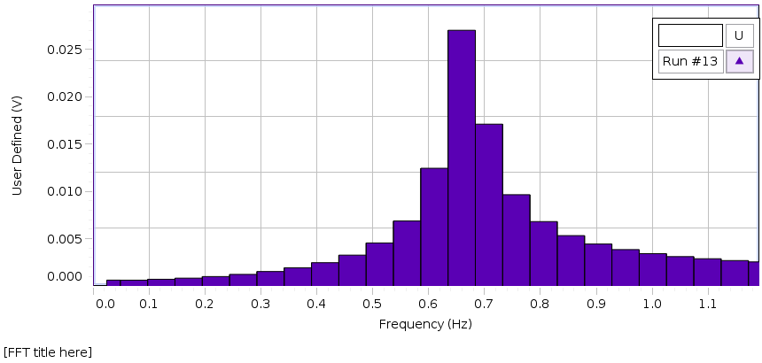

Figure 6. Fast Fourier Transform Method to find the Quality Factor Utilizing the FFT data, this bar graph gives a clear peak. The x-position of the peak gives ${f_{0}}_{best}$ to be approximately 0.68Hz. The step size, $∆f$, is visually approximated to be 0.05 Hz. Using these approximated values and Equation 5.14 from the lab manual1, was found to be 13.6, which is reasonable given that it is within a decent range of our calculated for our earlier found Q.

**Calculations:**

To find the damping time for the oscillation, we average the damping time for each ratio of successive normalized peaks. The damping time for one ratio is:

$$\frac{V(t+T)}{V(t)}=e^{\frac{-t}{τ}}$$

Where $V\left(t\right)$ is the voltage at time t, T is the period, which is 1.42±.05 s. $V(t+T)$ is the voltage one period away from t, and $τ$ is the damping time. This equation can be solved for $τ$ to get:

$$τ=\frac{T}{ln\left|\frac{V(t+T)}{V(t)}\right|}$$

Using this equation, the damping time for each ratio was found and then averaged to get a value of 5.05±.08 s for $τ$. Note that the voltages were normalized by subtracting the mean value from all of the data. The propagation of uncertainty for calculating this value is described in the Uncertainties section. From this value for the damping time, a value for *b* can be calculated using the equation $b=\frac{2m}{τ}$. From this, *b* is found to be 0.069±.006 kg/s. Using *b*, Q can now be calculated using the equation $Q=\frac{\sqrt{km}}{b}$. From this, Q is found to be 10.98±.06.

Now that all of the unknown experimental values have been calculated, the damped frequency, $f_{damped}$ can be calculated using the equation derived in the Derivation section:

$$f_{damped}=f_{0}\sqrt{1-\frac{m}{2bτQ^{2}}}$$

$f_{damped}$ is found to be 0.69 ± 0.04 Hz, which is very similar to the value for $f_{0}$ for the undamped oscillation, 0.69 ± .02 Hz. Given their uncertainties, these values are barely distinguishable, and can be considered essentially the same. These values are also very close to their predicted values, ${f_{d}}_{predicted}=0.70.05 Hz$ and ${f_{0}}_{predicted}=0.71.05 Hz$ which were found by inverting the time difference between two maxima, 1.42±.05 s. Because all of these predicted vs. measured values are essentially indistinguishable because they are within each other’s uncertainties, Eq. 5.2 from the lab manual was confirmed to correctly model the damped oscillation conducted.

**Conclusions**

The purpose of this experiment was to test whether the motion of a damped spring oscillation is modeled by Eq. 5.2 in the lab manual and to find the damping time, Q, of a damped oscillation.1 The oscillation was conducted, both damped and undamped, and the frequencies were calculated and compared to the expected frequencies based on the Eq. 5.2. The result was that the predicted and calculated frequencies were indistinguishable and, therefore, Eq. 5.2 was found to be valid. Q of our resonance was found to be 10.98±.06 using the equation method, and aprox. 13.6 using the FFT method. These values are fairly different, having a percent error of 23%, but this did not invalidate the results since it was understood that the value for Q found using the FFT method was an extremely rough estimation, since the values used to calculate it were extracted from the FFT graph via visual observation. One possible source of systematic error with this experiment is the forces of friction that could have damped the motion of the undamped oscillator. These forces were almost certainly present as evidenced by the slight decay in amplitudes over time in Figure 3. These unintended and unaccounted-for forces would also have affected the damped oscillator if they affected the undamped one. This would decrease the average peak height ratio for the damped oscillator, which would in turn increase the average damping time, which would then elevate the calculated frequency, hurting the results. However, since the results were extremely aligned with what was expected up to 2 decimal places, it is clear that this source of error did not affect the validity of the results. However, in order to obtain more precise results, the experiment could be conducted in an air-less environment. This degree of preciseness was not necessary and therefore the results obtained were deemed valid.

Bibliography:

1. Campbell, W. C. *et al*. Physics 4AL: Mechanics Lab Manual (ver. August 31, 2017). (Univ. California Los Angeles, Los Angeles, California).